Italian National Framework for Cybersecurity and Data Protection 2025 Compliance for Log360
Tagline: Align with Italy's cybersecurity best practices using integrated monitoring from Log360.

Overview
The Italian National Framework for Cybersecurity & Data Protection 2025 Compliance extension for Log360 enables Italian organizations to align with ACN's updated national cybersecurity framework across risk management, data protection, and incident response domains.
Log360 provides a unified view of security events across on-premises, cloud, and hybrid environments, enabling continuous monitoring and rapid incident response. Teams can map controls to framework categories, identify gaps, and maintain the evidence required for self-assessment and regulatory reviews.

Key Features
- Generate compliance reports mapped to Italian National Framework categories covering identify, protect, detect, respond, and recover functions.
- Monitor user access events, data handling activities, and system changes across all IT environments in real time.
- Centralize and correlate security events across your IT environment to surface threat patterns and suspicious activity aligned to the Italian National Cybersecurity Framework's detect and respond functions.
- Export audit-ready evidence in PDF and CSV formats for internal risk assessments and external regulatory submissions.
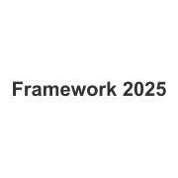
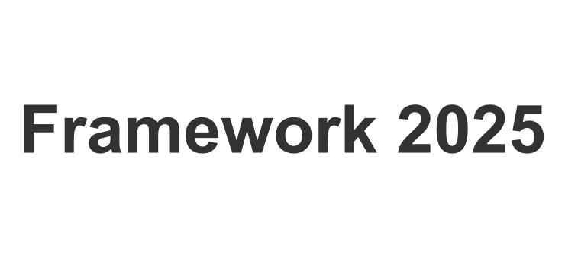

Screenshots
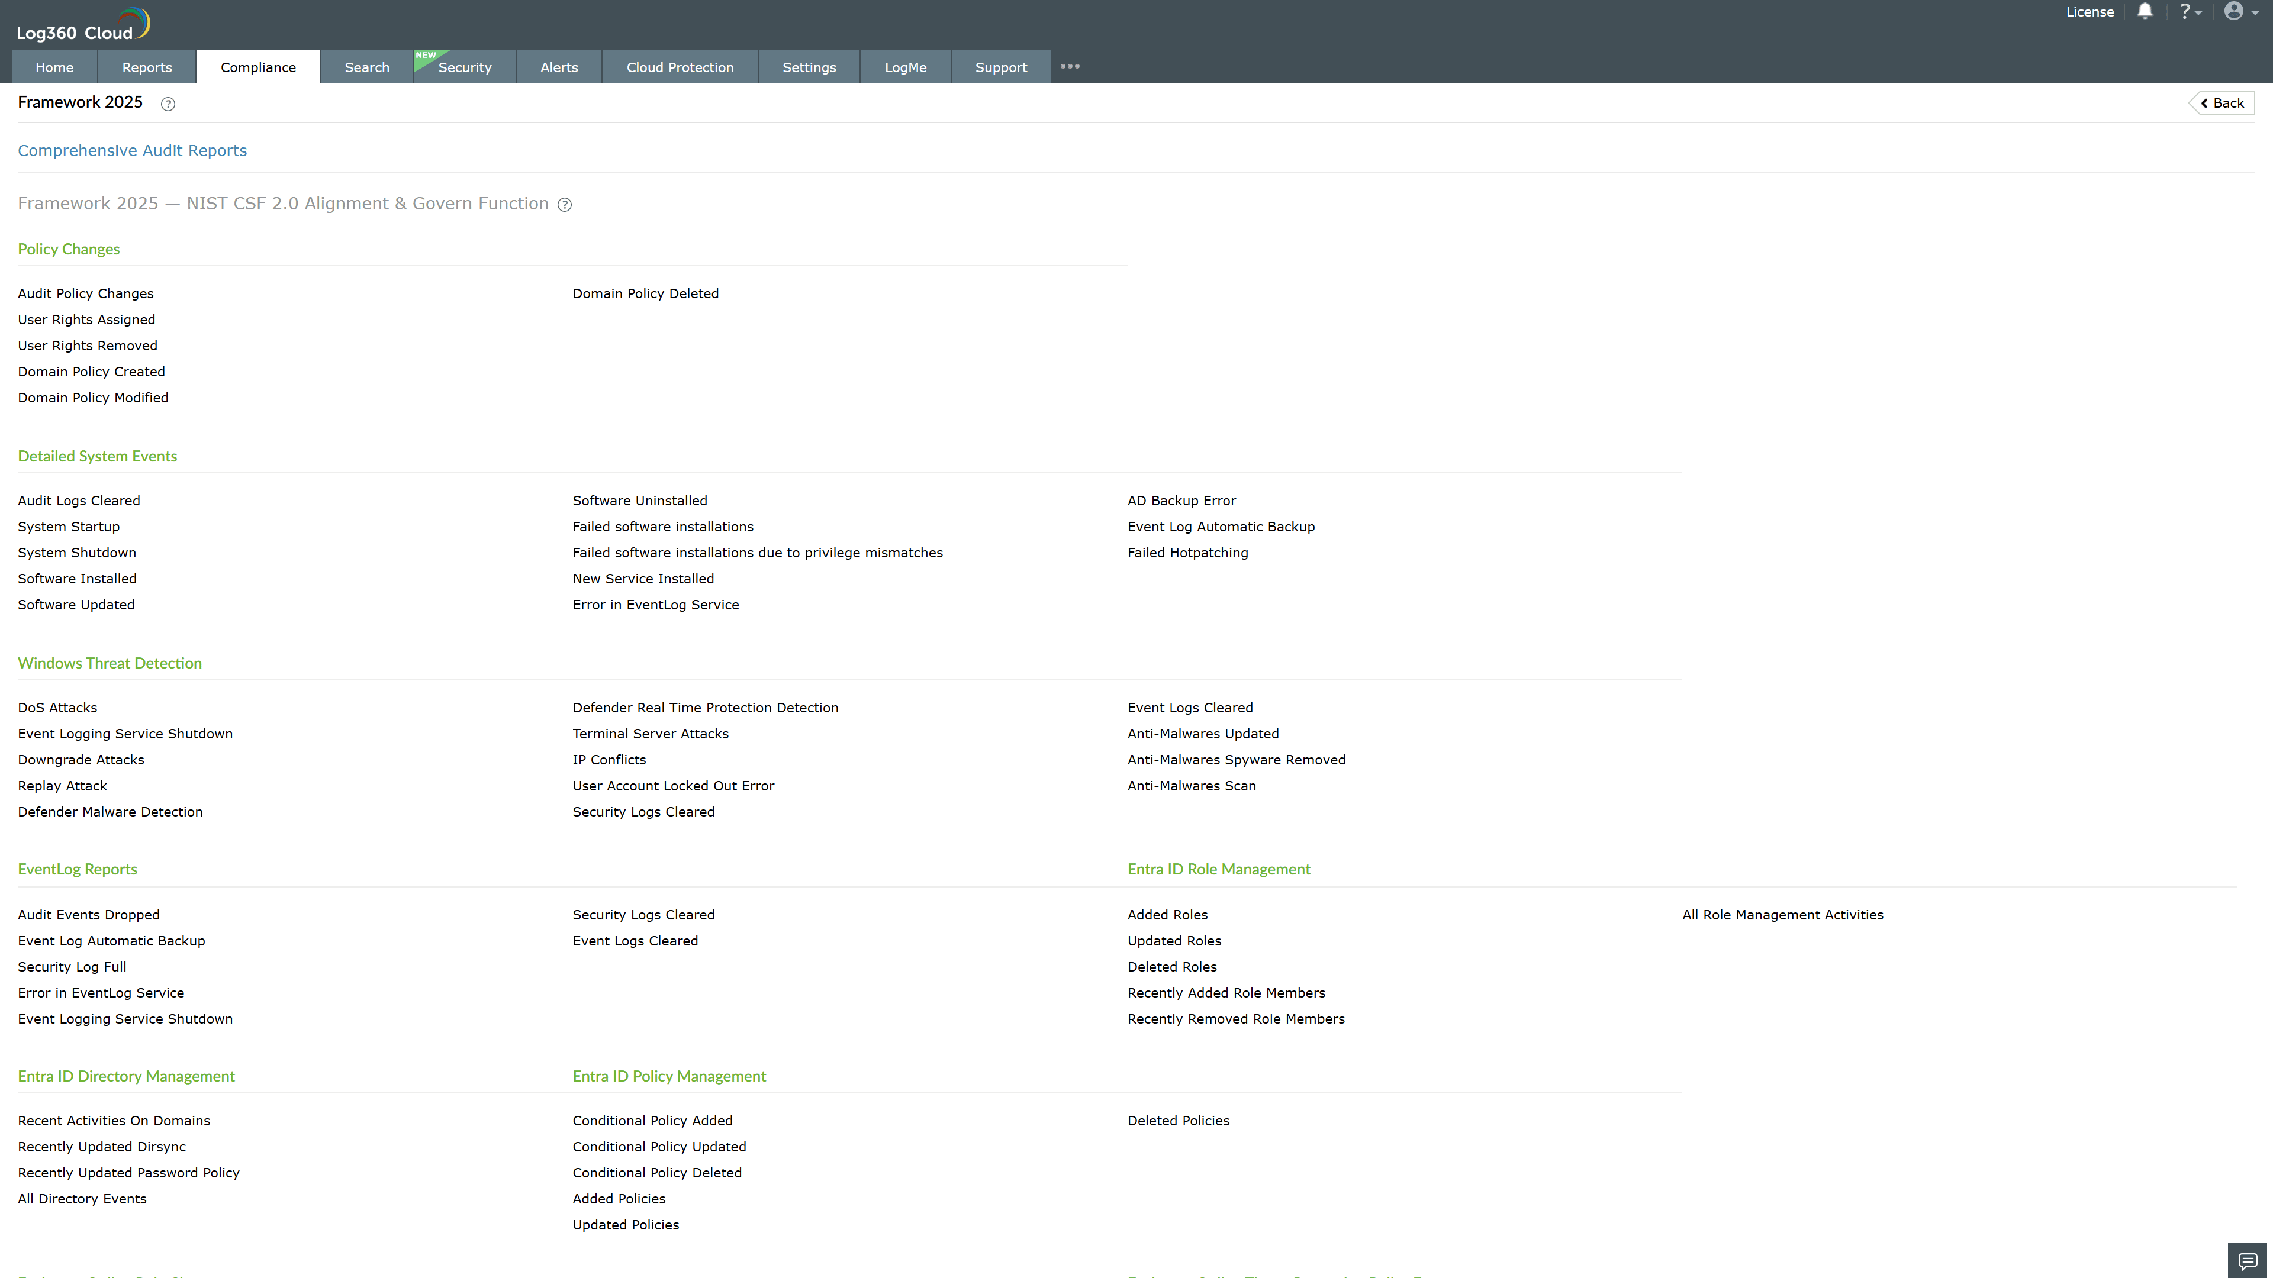
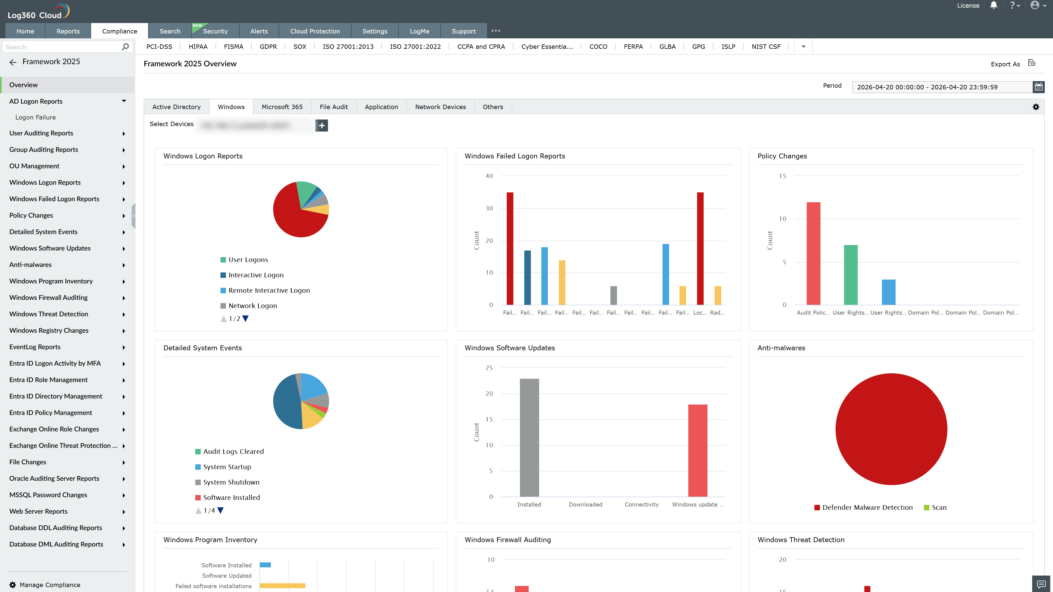
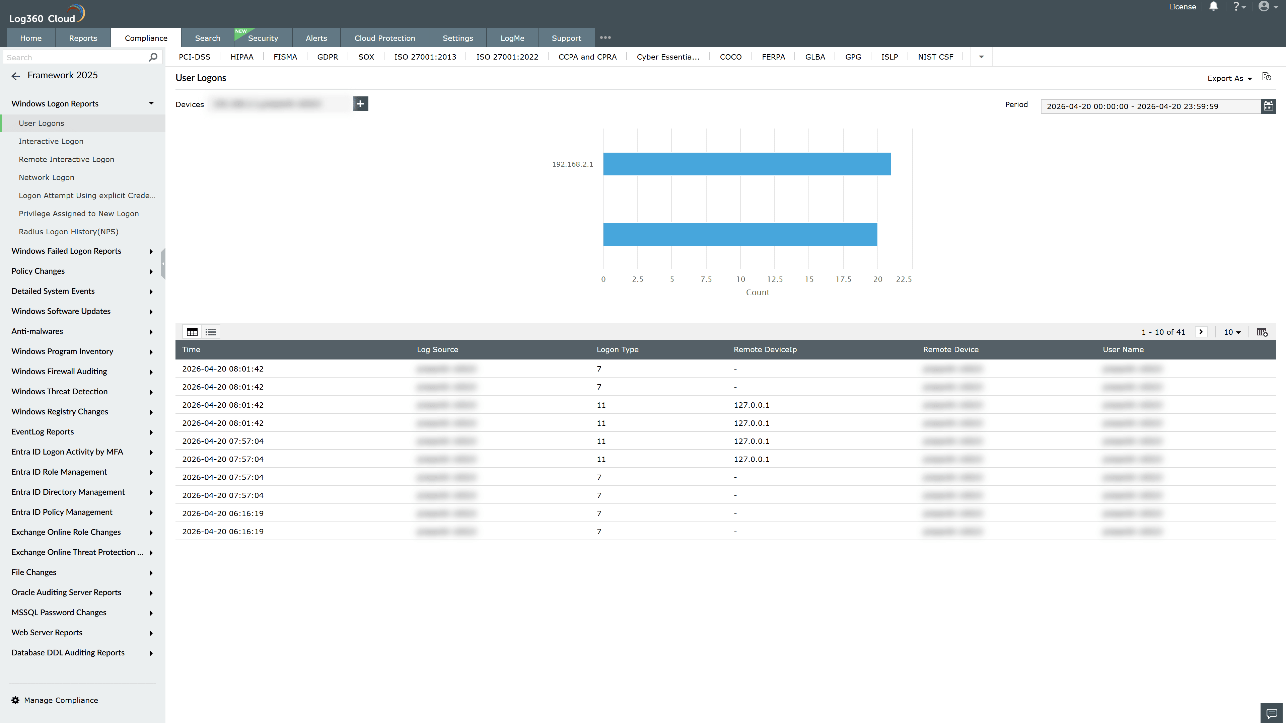
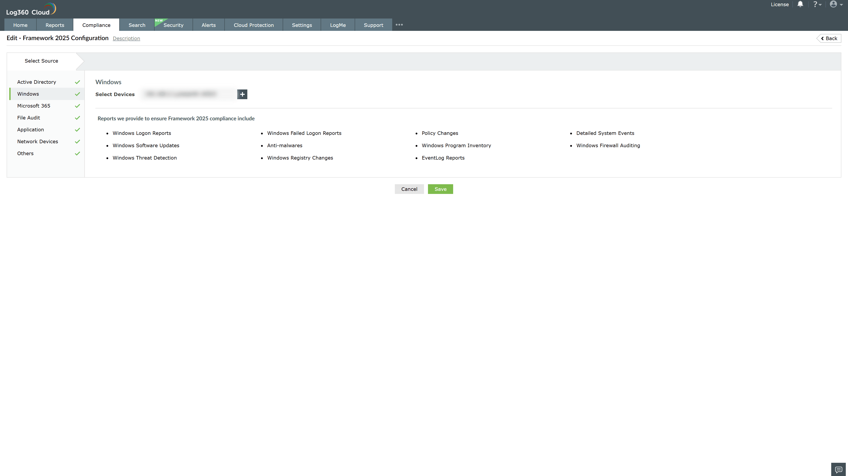

Valid Submission : Yes
Supported Editions : Free, Basic, Standard, Professional, MSSP
Help Document : https://www.manageengine.com/log-management/help/integrations/compliance-extensions.html
Help Video : Not provided
Tags : Log360, Compliance, Privacy monitoring, Data privacy, Regulatory compliance
Supported DCs : US, IN, JP, CA, AU, UK and EU
Privacy Policy:
Terms of Service:
Release Notes:
Predefined reports for the Italian National Framework for Cybersecurity & Data Protection 2025 Compliance

